

**Programme Name: ________BCs.IT_______________________________________**

**Course Code: __CSC 1403________**

**Course Name: ________Database concept______________________________**

**Assignment / Lab Sheet / Project / Case Study No. _5___**

**Date of Submission: _____June 22 2020_____________**

**Submitted By: Submitted To:**

**Student Name: Dipesh Tha Shrestha Faculty Name: Amar Subedi**

**IUKL ID: 041902900028 Department: PO**

**Semester: Second Semester**

**Intake: September 2019**

1. **List details of all departments located in block E.**

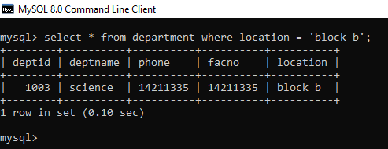***Answer***

1. **Change the course code for bachelor of multimedia from CIT304 to CIT306.**

***Answer***

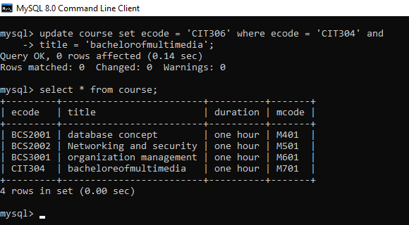

1. **List title ,start, and end date of all modules run in the diploma in information technology course.**

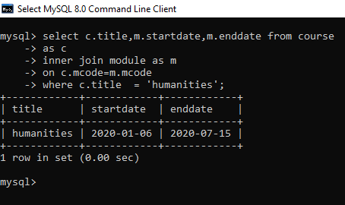***Answer***

1. **List name and qualification of all lectures who are employed by computer science department.**

***Answer***

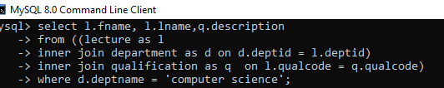

1. **Find the total number of modules where the start date is on 2017/11/30.**

***Answer***

